Cup Dispenser System Design

DOC. No.: | REV.: 00 |  |  | PRODUCT:
TITLE: Boiler detail design |  |  |  | Project:
Prepared by: | Scott Zhong |  |  | Date:
Remark: | Approval:
Remark: |  | Department | Title |  |  | Signature
Remark: | 1 | Electronic R&D
Remark: | 2
Remark: | 3
Remark: | 4

Revision | Description of Change | Author | Date
V0.0 | new | Scott Zhong | 8/9/2010

1. Cup dispenser system overview 4
2. The mechanical of Cup Dispenser System 4
3. Control Block 5
4. Modules and Components 6
4.1. Container Part 7
4.1.1. Control Flow 7
4.1.2. Data Structure and Enum 8
4.1.3. Container Control API 9
4.2. Table Part 10
4.2.1. Control Flow 10
4.2.2. Data Structure and Enum 11
4.2.3. Table Control API 12
4.3. Stick Part 13
4.3.1. Control Flow 13
4.3.2. Data Structure and Enum 13
4.3.3. Stick Control API 14
4.4. Canister Part 15
4.4.1. Control Flow 15
4.4.2. Data Structure and Enum 16
4.4.3. Canister Control API 16

Cup dispenser system overview
The cup dispenser system include below modules: two containers, two sticks, two dispensers, one sugar canister, one cup catcher, one auto door and one table.
When making product and dispense cup, these modules will work in sequence.

The mechanical of Cup Dispenser System
Figure2-1 and Figure2-2 illustrate The mechanical of cup dispenser system :
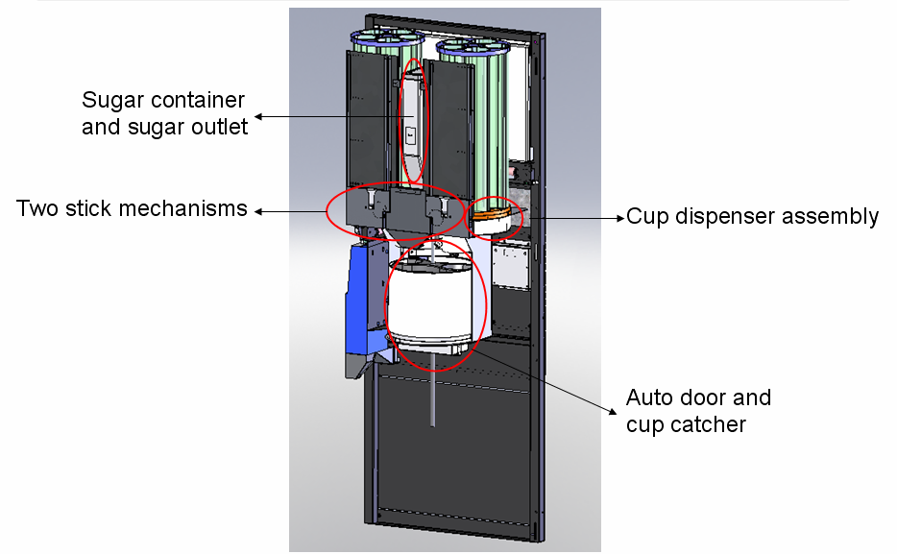
Figure2-1: cup dispenser system 1

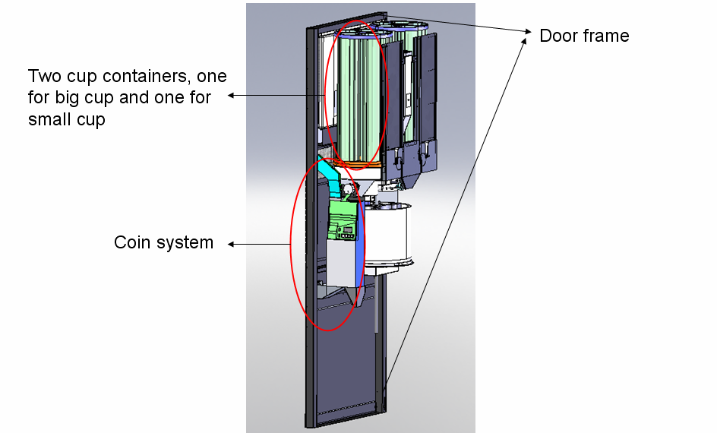
Figure2-2: cup dispenser system 2

Control Block
The cup board is controlled by the IO board. Cup board just work as a slave of IO board.
Figure3-1 illustrate the relationship of Main board, IO board and Cup board.
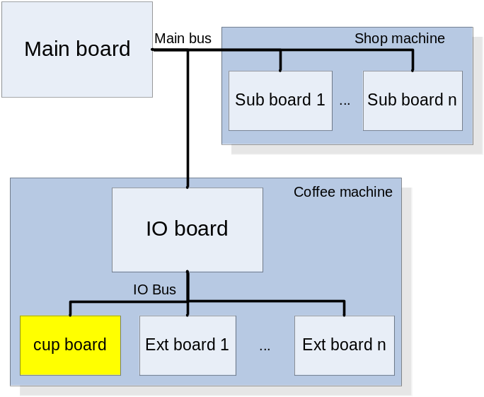
Figure3-1: Bus connection
Since the cup board just work as a slave, it can not let the modules work directly, all the commands are came from IO board, the cup board receive the commands and do the corresponding job.

Modules and Components
In the machine design, we separate the system into four parts:
- container part
This part include two cup containers and two cup dispensers
- table part
This part include the catcher, the auto door and the auto table
- stick part
This part include two stick mechanism
- canister part
This part include one canister

Each module in our design we see as a component.
The components ID define shows below:
enum
{
COMPONENT_BASE =100,
……
C_CANNISTER =1*COMPONENT_BASE,
……
C_CUP_CONTAINER =12*COMPONENT_BASE,
C_CUP_TABLE =13*COMPONENT_BASE,
……
C_STICK_DISPENSER =33*COMPONENT_BASE,
……
};

Please refer to Figure 4-1, this figure illustrates how the components behave in the machine design

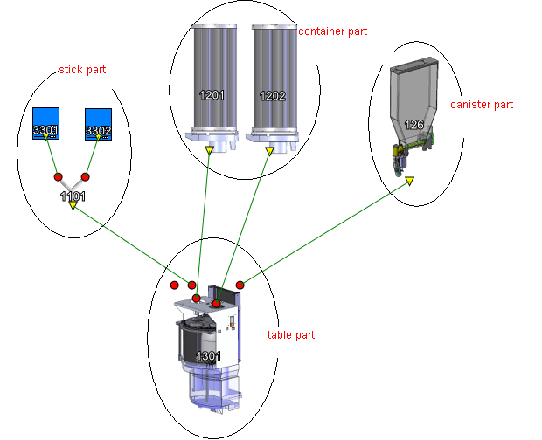

Figure4-1 components in machine design

Container Part
This part include two components, each component is combined with one container and one dispenser.
Here the cups will fill into the dispenser, and the dispenser will dispense the cup to the capture.

Control Flow
Figure4-2 shows how this component work when receive command
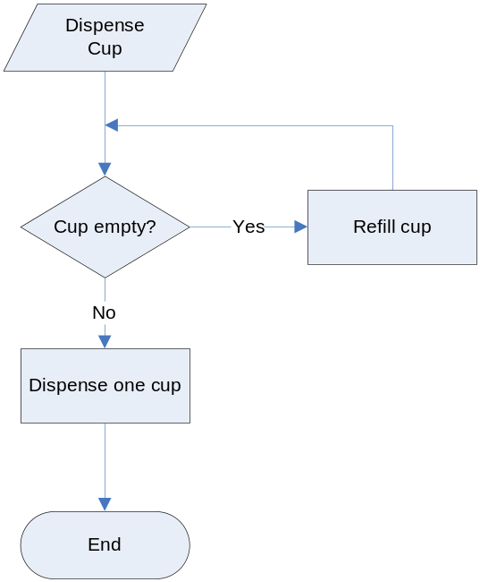

Figure4-2 Dispense cup flowchart

Data Structure and Enum
- Component ID
enum
{
COMPONENT_BASE =100,
……
C_CUP_CONTAINER =12*COMPONENT_BASE,
……
};

- Control ID
enum
{
CONTROL_DISP1_CUP_START = 0,
CONTROL_DISP1_CUP_HOME,
CONTROL_DRUM1_STEP,
CONTROL_DRUM1_TICK,
CONTROL_DRUM1_BACK,

CONTROL_DISP2_CUP_START,
CONTROL_DISP2_CUP_HOME,
CONTROL_DRUM2_STEP,
CONTROL_DRUM2_TICK,
CONTROL_DRUM2_BACK
};

- Control index
enum
{
CONTROL602_DISP1_CUP_START = 0,
CONTROL602_DISP1_CUP_HOME,
CONTROL602_CANISTER1_STEP,
CONTROL602_CANISTER1_TICK,
CONTROL602_CANISTER1_BACK,
……
CONTROL602_DISP2_CUP_START,
CONTROL602_DISP2_CUP_HOME,
CONTROL602_CANISTER2_STEP,
CONTROL602_CANISTER2_TICK,
CONTROL602_CANISTER2_BACK,
……
};

- Control structure
typedef struct
{
INT16 control;
INT16 speed;
INT16 timeOut;
INT16 P;
INT16 I;
INT16 D;
INT16 tachoCnt;
INT16 triggerCount;
} TIO_CONTROL;

Container Control API
static INT16 dispense_cup(INT16 component)
Prototype | static INT16 dispense_cup(INT16 component)
Description | Dispense cup
Input | Component ID
Output | no
Return | Error code

static INT16 handle_cup_dispense(INT16 componentNdx)
Prototype | static INT16 handle_cup_dispense(INT16 componentNdx)
Description | Handle cup dispense
Input | Component Ndx
Output | no
Return | Error code

static INT16 refill_cups(INT16 component)
Prototype | static INT16 refill_cups(INT16 component)
Description | Refill cup
Input | Component ID
Output | no
Return | Error code

static INT16 handle_refill_cups(INT16 component)
Prototype | static INT16 handle_refill_cups(INT16 component)
Description | Handle refill cup
Input | Component ID
Output | no
Return | Error code

static BOOLEAN handle_control(INT16 id, INT16 cmpIndex, INT16* pStatus)
Prototype | static BOOLEAN handle_control(INT16 id, INT16 cmpIndex, INT16* pStatus)
Description | Control component behavior
Input | control ID, Component Ndx
Output | Status
Return | OK or NOK

static BOOLEAN cup_empty(INT16 component)
Prototype | static BOOLEAN cup_empty(INT16 component)
Description | Check cup if empty
Input | Component ID
Output | no
Return | OK or NOK

Table Part
The table part is combined with one catcher, one auto door and one auto table, the whole table part is set into one component.
Here the catcher will catch the cup drop from the dispenser, and deliver to the output position; the auto door will open or close under control; and the table will move up or down under control.

Control Flow
Figure4-3 shows the flow of how the table works.

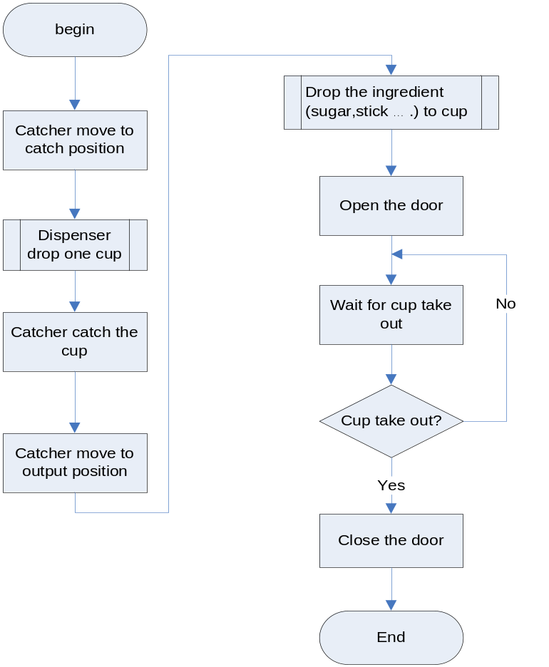

Figure4-3 table work flow

Data Structure and Enum
Component ID
enum
{
COMPONENT_BASE =100,
……
C_CUP_TABLE =13*COMPONENT_BASE,
……
};

Control index
enum
{
……
CONTROL602_CUP_CATCHER_FORWARD_HOME_POSITION,
CONTROL602_CUP_CATCHER_BACK_HOME_POSITION,
CONTROL602_CUP_CATCHER_FORWARD_ROTATE_ANGLE,
CONTROL602_CUP_CATCHER_FORWARD_ROTATE_ON_LEVEL,
CONTROL602_CUP_CATCHER_FORWARD_ROTATE_ON_EMK,
CONTROL602_CUP_CATCHER_BACK_ROTATE_ANGLE,
CONTROL602_CUP_CATCHER_BACK_ROTATE_ON_LEVEL,
CONTROL602_CUP_CATCHER_BACK_ROTATE_ON_EMK,
……
CONTROL602_DOOR_OPEN,
CONTROL602_DOOR_CLOSE,
……
CONTROL602_CUP_TABLE_UP,
CONTROL602_CUP_TABLE_CUP_DETECT_UP,
CONTROL602_CUP_TABLE_DOWN,
CONTROL602_CUP_TABLE_UP_TO_MIDDLE,
CONTROL602_CUP_TABLE_DOWN_TO_MIDDLE,
……
};

Control structure
typedef struct{
unsigned char velocity;
unsigned short timeout;
unsigned char P;
unsigned char I;
unsigned char D;
unsigned short emkCol;
}CStmParams;

typedef struct{
unsigned char ctrlNr;
CStmParams StmParams;
}extCtrlMsg;

Table Control API
static INT16 cupcatcher_to_home(void)
Prototype | static INT16 cupcatcher_to_home(void)
Description | Move catcher to home position
Input | no
Output | no
Return | OK or NOK

static INT16 cupcatcher_to_position(INT16 pos)
Prototype | static INT16 cupcatcher_to_position(INT16 pos)
Description | Move catcher to the special position
Input | Position
Output | no
Return | OK or NOK

static INT16 delivery_door_to_home(void)
Prototype | static INT16 delivery_door_to_home(void)
Description | Move door to home position
Input | no
Output | no
Return | OK or NOK

static INT16 open_delivery_door(void)
Prototype | static INT16 open_delivery_door(void)
Description | Open the door
Input | no
Output | no
Return | OK or NOK

static INT16 close_delivery_door(void)
Prototype | static INT16 close_delivery_door(void)
Description | Close the door
Input | no
Output | no
Return | OK or NOK

static INT16 move_table_position(INT16 pos)
Prototype | static INT16 move_table_position(INT16 pos)
Description | Move table to the special position
Input | no
Output | no
Return | OK or NOK

static void check_no_holder(void)
Prototype | static void check_no_holder(void)
Description | Check and wait till the holder has been taken out from the deliver position
Input | no
Output | no
Return | no

static void check_cuptable_no_holder(void)
Prototype | static void check_cuptable_no_holder(void)
Description | Check and wait till the holder has been taken out from the cup table
Input | no
Output | no
Return | no

Stick Part
This part has two components, one stick mechanism as one component.
The stick mechanism just does the job that dispenses stick.

Control Flow
Figure4-4 shows the flow of dispense stick

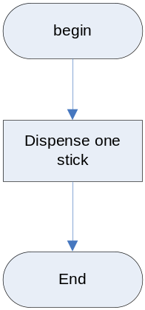

Figure4-4 dispense stick flow

Data Structure and Enum

Component ID
enum
{
COMPONENT_BASE =100,
……
C_STICK_DISPENSER =33*COMPONENT_BASE,
……
};
Control index
enum
{
…
CONTROL602_DISPENSE_STICK1,
CONTROL602_DISPENSE_STICK1_ON_EMK,
CONTROL602_DISPENSE_STICK1_BACK,
CONTROL602_DISPENSE_STICK1_BACK_ON_EMK,
….
CONTROL602_DISPENSE_STICK2,
CONTROL602_DISPENSE_STICK2_ON_EMK,
CONTROL602_DISPENSE_STICK2_BACK,
CONTROL602_DISPENSE_STICK2_BACK_ON_EMK,
….
CONTROL602_DISPENSE_DETECT_STICK1,
CONTROL602_DISPENSE_DETECT_STICK1_ON_EMK,
CONTROL602_DISPENSE_DETECT_STICK1_BACK,
CONTROL602_DISPENSE_DETECT_STICK1_BACK_ON_EMK,
CONTROL602_DISPENSE_DETECT_STICK2,
CONTROL602_DISPENSE_DETECT_STICK2_ON_EMK,
CONTROL602_DISPENSE_DETECT_STICK2_BACK,
CONTROL602_DISPENSE_DETECT_STICK2_BACK_ON_EMK,
…
}
Control structure
typedef struct STICK_SYSTEM_Tag
{
INT16 componentId;
const STICK_INTERFACE *stickVFunc;
}STICK_SYSTEM;

typedef struct{
unsigned char velocity;
unsigned short timeout;
unsigned char P;
unsigned char I;
unsigned char D;
unsigned short emkCol;
}CStmParams;

typedef struct{
unsigned char ctrlNr;
CStmParams StmParams;
}extCtrlMsg;

Stick Control API
static IO_RESULT drop_stick(STICK_SYSTEM *me)
Prototype | static IO_RESULT drop_stick(STICK_SYSTEM *me)
Description | Drop one stick
Input | Stick control structure
Output | no
Return | Error code

static INT16 handle_stick_motor(INT16 cNdx,INT16* pStatus,INT16 speed)
Prototype | static INT16 handle_stick_motor(INT16 cNdx,INT16* pStatus,INT16 speed)
Description | Handle the stick motor
Input | Component Ndx, run speed
Output | Status
Return | Error code

static IO_RESULT remote_stick_control_1(INT16 boardAddress,INT16 *pStatus)
Prototype | static IO_RESULT remote_stick_control_1(INT16 boardAddress,INT16 *pStatus)
Description | Drop stick type 1
Input | Board address
Output | status
Return | Error code

static IO_RESULT remote_stick_control_2(INT16 boardAddress,INT16 *pStatus)
Prototype | static IO_RESULT remote_stick_control_2(INT16 boardAddress,INT16 *pStatus)
Description | Drop stick type 2
Input | Board address
Output | status
Return | Error code

Canister Part
This part just only combines with one extended canister. Just like the local canister, this canister holds ingredient. When you drive the motor, the spindle will push the ingredient out of the canister.

Control Flow
Figure4-5 shows the flow of dosing.
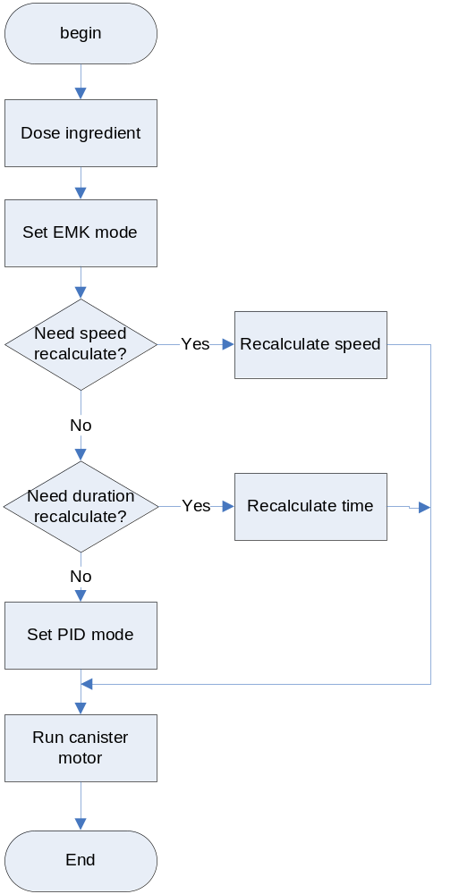

Figure4-5 canister dosing flow

Data Structure and Enum
Component ID

enum
{
COMPONENT_BASE =100,
……
C_CANNISTER =1*COMPONENT_BASE,
……
};

Control index
enum
{
……
CONTROL602_SUGER_DRIVER_FORWARD
……
};

Control structure
typedef struct CANNISTER_SYSTEM_Tag
{
INT16 componentId;
CANNISTER_INTERFACE const * cannisterVFunc;
}CANNISTER_SYSTEM;

typedef struct{
unsigned char velocity;
unsigned short timeout;
unsigned char P;
unsigned char I;
unsigned char D;
unsigned short emkCol;
}CStmParams;

typedef struct{
unsigned char ctrlNr;
CStmParams StmParams;
}extCtrlMsg;

Canister Control API
static INT16 dose_cannister(INT16 cannisterId,INT16 amount,INT16 iDelay,
INT16 speed,INT16 uDelay,INT16 extension)
Prototype | static INT16 dose_cannister(INT16 cannisterId,INT16 amount,  INT16 iDelay,INT16 speed,INT16 uDelay,INT16 extension)
Description | Dose ingredient
Input | Canister Id, amount, begin delay, motor speed, duration, extension time
Output | no
Return | Error code

static IO_RESULT start_motor(CANNISTER_SYSTEM *me, BYTE actuationMode,
INT16 speed, INT16 actuationValue,INT16 maxDuration)
Prototype | static IO_RESULT start_motor(CANNISTER_SYSTEM *me,  BYTE actuationMode,INT16 speed, INT16 actuationValue,  INT16 maxDuration)
Description | Start canister motor
Input | Canister control structure, control mode, motor speed, EMK value, max duration
Output | no
Return | Error code

